SOFTWARE AND HARDWARE SYSTEM OF MONITORING HIGH-VOLTAGE ELECTRIC EQUIPMENT BASED ON THE ANALYSIS OF PARTIAL DISCHARGE CHARACTERISTICS

Gataullin Ayrat Muhamedovich
IEEE
KSPEU
Russian Federation
gataullin1969@gmail.com

Gubaev Damir Fatihovich
IEEE
KSPEU
Russian Federation
d-gubaev@mail.ru
Gataullina Rosa Wilurovna
Institute of Economics
KSAU
Russian Federation
rosa-5@mail.ru

Abstract—the reliability of the high-voltage electrical equipment insulation can significantly affect the equipment lifetime, taking into account the operating conditions and the stability of the power system. Insulation degradation can occur gradually and continuously even during normal operation. Thus, maintenance work must be carried out in a timely manner in order to prevent the threat of equipment damage and limitation of the supply of electrical and thermal energy to the consumers, for example, due to the violation of the electrical equipment insulation characteristics, which often leads to short circuits and accidents in the power system. Currently, monitoring systems used in the operation of power equipment are aimed at early detection of damages. At digital substations of a new generation using SF₆ equipment, the partial discharge method is one of the main ones for solving this problem.) Insulation degradation may occur gradually and continuously even during normal use. Therefore, maintenance work must be carried out in a timely manner to prevent equipment failure. To register and analyze the statistical parameters of partial discharges, a hardware-software system (HSS) based on the National Instruments Compact RIO (NI Compact RIO) equipment and the LabVIEW graphical programming system is proposed. HSS can be used to diagnostic the state of power transformers and autotransformers.
Keywords — high-voltage electrical equipment monitoring system, partial discharges, partial discharges method, automation of the electrical high-voltage equipment state diagnostics, smart grids, digital transforming substations

Introduction
Currently, the monitoring systems of the high-voltage electrical equipment state solve the problems of the early faults detection. [1, 2]. Partial discharges (PDs) originate in insulation of the power electrical installations. Partial discharges can lead to gradual wear and accelerated aging of the insulation and, therefore, can lead to the complete insulation breakdown [3]. Thus, detection of PDs and their characteristics analysis is an important tool for diagnosing of the insulation state when servicing the electrical equipment. The IEC 60270 standard, which is based on the PDs contact method, is generally used to check the condition of the insulation. Alongside with the contact method, a number of contactless methods of the PDs characteristics registration and analysis are used. These methods refer to the detection of PDs based on physical phenomena caused by PDs, such as electromagnetic (EM) waves, acoustic waves, chemical effects, etc. [4, 5, 6, 7]. Given the potential limitations of the IEC 60270 method, which is sensitive to external noise and interference, PDs detection in the ultrahigh frequency (UHF) region of electromagnetic radiation (EMR) has attracted the researcher’s attention over the past few decades. Partial discharge detection using UHF sensors has a number of advantages due to immunity to external electromagnetic interference and, therefore, is more suitable for monitoring systems compared to other methods [8, 9]. The rise time of the PDs can be less than 1 ns, for example, in oil insulation [10]. Such a short pulse can emit EM waves with frequency components in the decimeter range, i.e. from 300 MHz to 3 GHz. For PDs register in such a frequency range, UHF antennas are required. For the first time, PDs registration in the UHF range of EMR was applied in SF₆ substations [11], and then this method was applied to power transformers [12] and cables [13]. In recent years, several review works have been carried out related to the analysis of PDs characteristics in the UHF range of EMR in terms of PDs processing, their localization [14, 15] and recognition of their characteristics, especially in the UHF EMR range [16] for the development of monitoring systems for various high-voltage electrical equipment, including cables [17] and porcelain insulators [18]. However, so far no system has been proposed for monitoring of the high-voltage electrical equipment insulation state based on the analysis of PDs characteristics using various PDs sensors as part of a single software and hardware system (HSS). The article briefly lists the main aspects of the high-voltage electrical equipment state diagnosing, provides a brief overview of the possibilities and ways of the monitoring systems improvement for high-voltage electrical equipment. For registration and analysis of the partial discharges statistical parameters, a HSS based on the National Instruments Compact RIO (NI Compact RIO) equipment and the LabVIEW graphical programming system is proposed.
HSS can be used to diagnose the of power transformers and autotransformers state. First of all, HSS can be used on high-voltage power transformers with voltage from 110 kV and higher at digital SF₆ substations.

Summary Of NI CompactRIO and NI LabVIEW Capabilities For PSS Implementation
Power transformers monitoring systems differ in the controlled parameters number. At the same time, the following operational parameters of high-voltage electrical equipment are the most important: moisture content in oil, gas content in oil (CO, CO₂), statistical parameters of partial discharges in high-voltage bushings, dielectric loss tangent, main insulation capacitance, control of conduction currents of a three-phase bushing system, control of parameters operation of the cooling system, oil temperature at various points, oil pressure in oil-filled inlets.
The monitoring systems are equipped with an automated workstation (AWS), including diagnostic software, and one or more monitoring units.
It is obvious that in order to increase the effectiveness of the diagnosing methods for the high-voltage electrical equipment state, it is necessary:
1. The possibility of placing several data collection boards and sensors for various purposes in one PSS at the same time, depending on production tasks needs. Due to this modular arrangement, the composition of data acquisition boards and sensors can be changed depending on current production tasks;
2. The ability to reliably upgrade the HSS software, including databases, graphical representation of data, calculation results, methods for transmitting diagnosed data, etc. by specialists without special education.
It is obvious that the development of such a HSS will make it possible to create a flexible modular system for monitoring the state of high-voltage electrical equipment, easily reconfigured depending on the production tasks set without excessive unjustified costs. In our opinion, the NI Compact RIO equipment is suitable for the implementation of the HSS: an FPGA system operating in real time, manufactured by NI. FPGA stands for Programmable Logic Integrated Circuit. A feature of NI Compact RIO is its ability to operate in industrial conditions in real time under any weather conditions, with a relatively high sampling rate of analog signals and a high speed of signal transmission to the workstation. The NI Compact RIO is programmed using the LabVIEW graphics software system, which does not require any advanced programming knowledge.
The NI Compact RIO is a programmable automation controller designed for fully functional prototyping and implementation of off-the-shelf test and measurement systems. The NI Compact RIO is a feature-rich, embeddable data acquisition and control system designed for applications that require high performance and reliability in measurement and control systems. Reason to its open architecture, compact size, and mechanical strength, NI Compact RIO can be used to solve the most complex technical problems. In addition, NI Compact RIO is an embedded test and measurement system based on reconfigurable I/O technology. These capabilities make the NI Compact RIO suitable for PSS development. The NI Compact RIO platform consists of an integrated FPGA chassis, a real-time controller, and I/O modules. NI Compact RIO can be used as a single platform for PSS development in the lab, and PSS implementation in field conditions. This flexibility of NI Compact RIO is due to the tight integration of the hardware and the LabVIEW graphics development environment. With LabVIEW, you can carry out the entire project development cycle on the NI Compact RIO, using specialized software modules and libraries, such as LabVIEW Real-Time, if necessary, and also easily create a convenient user interface for the AWP. The flexibility of a PSS designed with the NI Compact RIO will be provided by the NI Compact RIO Embedded Chassis (fig. 1). The chassis core is an FPGA for reconfigurable I/O signals. Each I/O module has direct access to FPGA channels and is programmed using simple I/O functions. The input/output of signals from each module is precisely synchronized (with an error of 25 ns), due to the direct connection of the modules to the FPGA signal lines. The interface between the FPGA and the real-time controller is the PCI bus. The real-time controller synchronizes the operation of the I/O modules with an error of 25 ns.

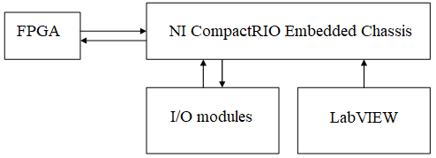
Fig. 1. Block diagram of the NI CompactRIO Embedded Chassis.

Embedded FPGA allows you to reconfigure embedded applications and process data in parallel at a frequency of 40 MHz. NI offers more than 100 I/O modules, including temperature measurements, vibration measurements, analog and digital I/O, drive control, industrial communication protocols, voltage and current I/O. It is possible to connect any sensors to the developed modules and create your own modules based on a ready-made developer kit. Using the LabVIEW graphical programming environment and the LabVIEW Real-Time library of functions, it is easy, without special programmer training, to implement the graphical user interface of the AWP, including using touch panels. The LabVIEW Real-Time Function Library is designed for programming NI Compact RIO real-time controllers in LabVIEW. In LabVIEW, you can assign code execution priorities to NI Compact RIO real-time controllers. The LabVIEW FPGA Function Library is designed for programming the NI Compact RIO FPGA in LabVIEW. LabVIEW has the ability to create a convenient local and WEB interface to control the NI Compact RIO from anywhere in the world. There are necessary libraries to ensure the operation of sensors of any type. NI offers the NI TPC - 2106/ 2012/ 2115/ 2512/ 2515 panel computers for remote control of NI Compact RIO platforms using a human-machine (HMI) interface, running applications under the control of LabVIEW Real-Time in industrial distributed systems that for the user are a touch panel and a set of AWP controls capable of continuous operation in harsh industrial environments. Thus, in the HSS based on NI Compact RIO and the LabVIEW graphical programming environment, it is easy to implement the simultaneous measurement of several information streams from sensors of various types, with subsequent analysis of this information, which will increase the accuracy of predicting the state of insulation of high-voltage electrical equipment. In this paper, the focus is on synchronous PDs measurements from an FM receiver and EMR recorded by a telescopic antenna.

Main results with FM Receiver
Fig. 2, 3 show the PDs recorded by the FM receiver. It can be seen that the sensitivity of the FM receiver makes it possible to record signals that differ in amplitude by 1 mV, which corresponds to 10 pC in terms of apparent charge. This conclusion was made on the basis of a comparison of the PD signals obtained using an FM receiver and a standard PDs recording device.

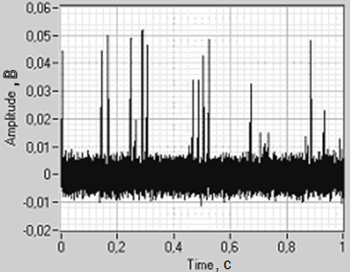Fig. 2. PDs received by FM receiver.

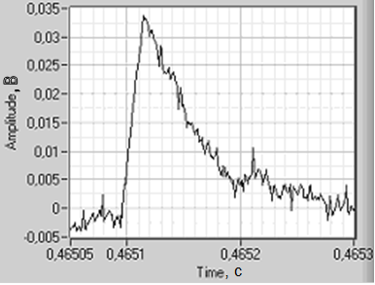
Fig. 3. PDs recorded with an FM receiver (PD peaks are clearly visible on the decay of the pulse front).

The block diagram of the NI LabVIEW software virtual instrument includes such elements as DAQ assistant designed to set signal digitization parameters, including setting the digitization cycle duration (1 s), digitizing frequency (1 MHz), Formula Node contains input and output parameters, is designed for data processing using software modules written in the C programming language (Fig. 4).
The PDs after filtering and amplification were transferred to LabVIEW for further processing, including those received from the antenna (Fig. 5, 6). The PDs source was a standard surface-needle test system. The needle diameter was 20 μm, the distance to the surface varied from 3 to 5 cm, the applied voltage varied up to 18 kV, up to the breakdown of the discharge gap.

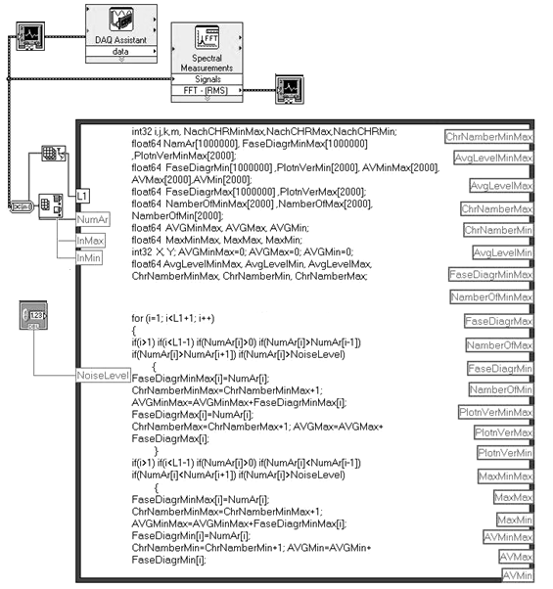Fig. 4. Block diagram of the NI LabVIEW Software VI.

The studies were carried out both at constant and alternating applied voltage. Of particular interest is the pre-breakdown situation (Fig. 8). It can be seen that the amplitude of the PD signals in the pre-breakdown situation, regardless of the nature of the operating voltage (AC or DC), increases sharply, the leading edge of the PD signals is delayed, and against the background of the trailing edge, PD pulses intersecting each other are observed.
Next, amplitude-phase diagrams are built of PDs (Fig. 8). Comparing the PDs data in this way, primarily the amplitude-phase diagrams, two-dimensional PDs distributions, one can draw a conclusion regarding the state of the insulation of high-voltage electrical equipment.
Artificial neural networks are effective for automating the isolation state diagnostics. To train artificial neural networks, a large amount of data is needed, and for this NI Compact RIO is indispensable.

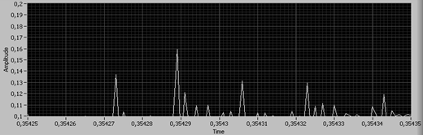Fig. 5. 11 kV DC. The signal was received using an RC antenna (time constant 14 µs). The situation is far from pre-breakdown.

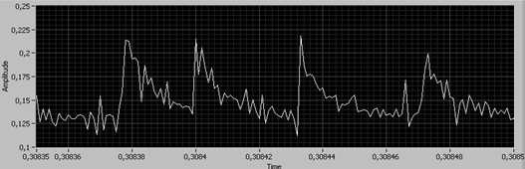Fig. 6. 14 kV DC. The signal was received using an RC antenna (time constant 14 µs). Pre-breakdown situation.

Fig. 7. 18 kV AC. The signal was received using an RC antenna (time constant 14 µs). Pre-breakdown situation.

Fig. 8. Distribution of positive values of PDs signals in amplitude, phase and number of PDs coordinates.

Comparison of PDs Characteristics By Contact And UHF Methods
From the study can be done conclusions: the high-frequency components of the signal are superimposed on the low-frequency components, the response to PDs at a DC applied voltage well correlate with the response at an AC applied voltage (fig. 9, 10, 11). From point of view reducing the influence of corona discharges, UHF receiver is more perspective at DC applied voltage and as well as AC applied voltage (fig. 10). For effective separation of the source of PDs, it is advisable to use different frequency ranges, therefore, in the practical implementation of the PD method, from the point of view of the author, it is more promising to use standard receivers. For these purposes, it can be applied a network of receivers connected to the PSS.

Fig 9. 1 – FM channel, 2 – contact channel. DC applied voltage 8 kV

Fig. 10. AC 7 kV. FM recivier tuned to 434 MHz.

HSS based on NI Compact RIO equipment and the LabVIEW graphical programming environment can effectively solve the problems of monitoring the state of high-voltage electrical equipment in terms of partial discharge parameters, including pre-emergency and emergency modes. The HSS based on NI Compact RIO equipment consists of a number of modules and chassis, so it can be eaily reconfigured depending on the tasks and can be used on high-voltage equipment, including power transformers and autotransformers. For this it is requires further work on collecting statistical information about PDs, training artificial neural networks based on its analysis, as well as known expert rules.

Fig. 11. 1–DC applied voltage 8 kV, 2–AC allied voltage 8 kV,HF PDs registration standart device sensor

Conclusion
PSS is equipped with all necessary hardware and software, including communication channels for transmitting information over a distance. NI Compact RIO has powerful software based on the LabVIEW and C programming language for visualizing the PDs, calculating the PDs characteristics, and calculating the source of PDs intensity. The FM receiver is a standard device operating in the HF wavelength range. Up to 8 of these type receivers can be connected to one NI Compact RIO, which makes such a system very perspective for monitoring the condition of, for example, a power transformer. The detailed review of the monitoring system based on the proposed system is beyond the pale of the presented paper.

